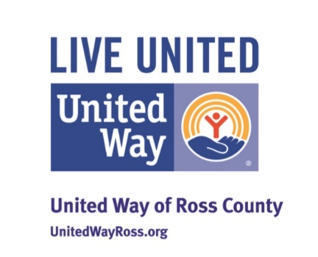

United Way Ross County COVID 19 Response and Recovery Fund
Grant Application

All submissions must be received through the website for consideration at info@unitedwayross.org

ORGANIZATION INFORMATION

- Organization Name
- Organization Primary address (headquarters/main office)
- Is your organization a registered 501(c)3 nonprofit

Please provide your Tax ID Number:
Please send a copy of your letter from the IRS.

If you are not a 501(c) 3 organization who is serving as the fiscal sponsor for this project?
    - Fiscal sponsor organization name • Fiscal sponsor address
    - Fiscal sponsor primary contact name
    - Fiscal sponsor primary contact email
    - Fiscal sponsor Tax ID Number

Main Contact Information
This contact will receive automated communications for this questionnaire on behalf of your organization.
Main Contact Name
Main Contact Email
Main Contact Main Role
    - Chief Executive
    - Grant Program/Project Lead
    - Financial Lead
Main Contact Phone Number

Additional Contacts
These contacts are required. If this role is not filled for your organization, please enter n/a
Chief Executive/Grant Program/Financial Name
Chief Executive/Grant Program/Financial Email
Chief Executive/Grant Program/Financial Name
Chief Executive/Grant Program/Financial Email

- Organization mission and vision

- What Year did you being providing services in the Ross County Area?

REQUEST INFORMATION

- Service area for the grant (must be in Ross County)– please indicate

- If your COVID-19 response efforts will support more than one fund priority area, please indicate which other areas your efforts are supporting. Please indicate all that apply:

  - Education
  - Emergency Financial Assistance
  - Food Security
  - Health
  - Housing

8.Briefly describe your organization’s response to the coronavirus pandemic in Ross County. Include a description of services being provided and demographics of people being served. Please describe if the population your organization is serving in your COVID-19 response efforts is different from or expanded on the population you normally serve.

9.If your organization is addressing any specific barriers that people may be facing at this time, please be sure to describe the barrier and how you are addressing it. (i.e. high risk for exposure to COVID-19; physically differently abled; mental health instability; low-income due to COVID-19 related loss of work; experiencing homelessness; domestic violence survivor; etc.)

FINANCIAL INFORMATION

10.What is the total funding need for your COVID-19 response in the next 60-90 days?

11. How much funding are you requesting from the COVID-19 Fund?

12.If you have already secured commitments or support for these efforts, who are the funders and how much has been committed? Please include whether your organization has been able to access, or anticipate receiving, any government funding as a result of your COVID-19 response, and the details of that funding.

13.Provide total revenues and expenses from the last fiscal year.

14. Registered with the Ohio Attorney Charitable Registration https://charitableregistration.ohioattorneygeneral.gov/ . Please include a copy of your current registration.

15. Upon completion of the project please send us a description of how funds were used and receipts. Please let us know how many people you served.

