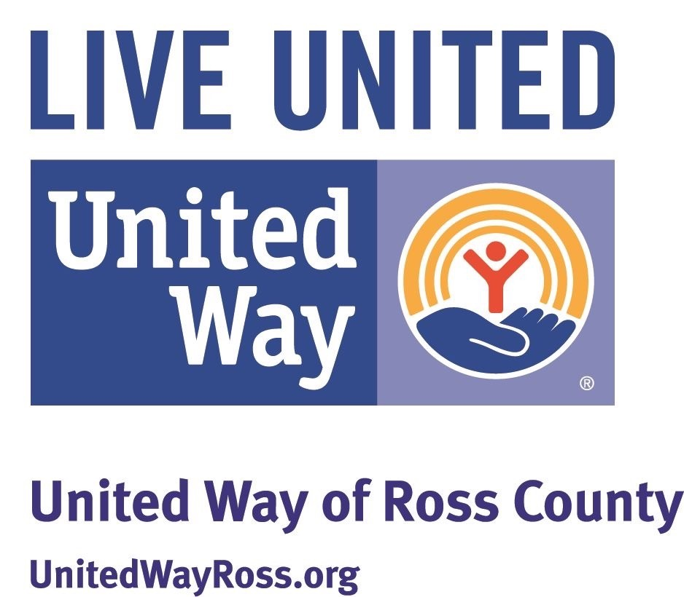

United Way of Ross County
COVD-19 Micro Grants Fund Request Form

(A.) Name:

(B) Request:

(C) Explanation of Project: (How will you use COVID-19 Micro funds?) Under 500 words. Use separate sheet if needed.

- Cost of Project:

- Conclusion:

* * * * * * * * * * * * * * * * * * * * * * * * * * * * * * * * * * * * * * * * * * * * * * * * * * * * * * * * * * * * * * *

Requirements

1. Must be non-recurring and/or extraordinary expenditure.
- Agency making request should:

a. Be incorporated, Not for Profit and IRS exempt, or K-12 Educational facility.
b. Offer or provide human service program(s) or a community service based on documented needs.
c. Be non-discriminatory.
d. Have active rotating volunteer leadership that represents diverse elements of the community.
e. Have sound financial and program management.
Note: Email your request to info@unitedwayross.org

grant request. form

